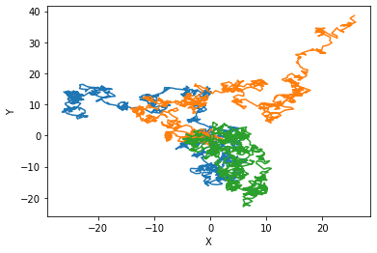

Describing something as “random” or “not random” is difficult, as, generally speaking, the human brain has a hard time understand what is truly random. While the odds are low, a 1000 step walker could just take steps back and forth between the same too points, and it still be completely random. With that said, yes I believe that these are all random “walks”. There doesn’t appear to be any order to the movements.